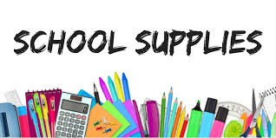
Grade 1 List

- Headphones (labelled with your child’s name) for iPads
- Lunchbox/Backpack
- Indoor Sneakers (please no tie shoes if students are unable to tie on their own)
- Water bottle (no fountains, only water bottle refilling stations available)
- Masks (subject to change)
- $50 student fee

Grade 1 List

- Headphones (labelled with your child’s name) for iPads
- Lunchbox/Backpack
- Indoor Sneakers (please no tie shoes if students are unable to tie on their own)
- Water bottle (no fountains, only water bottle refilling stations available)
- Masks (subject to change)
- $50 student fee

